Title: ON9 FX System

Business: Foreign currencies exchange services

ERD:

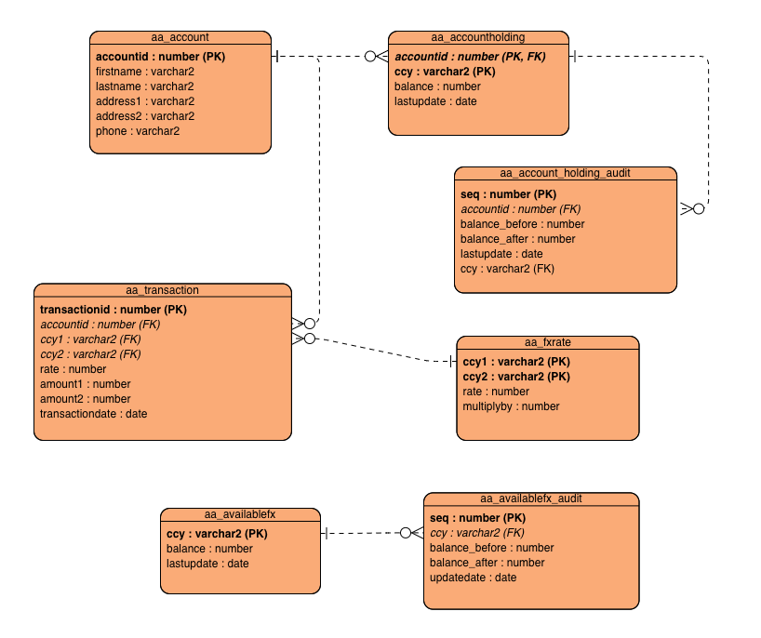

Func:

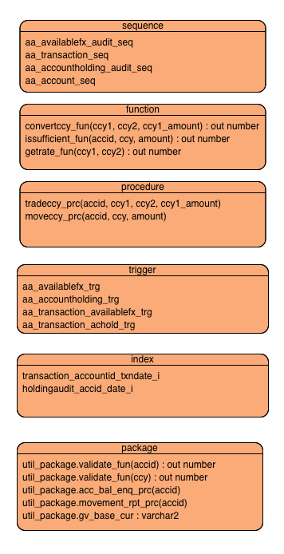

Customer Fx rate ***Enquiry*** (SQL)

Customer account ***Enquiry*** (SQL + function rateConvert)

Customer ***PlaceOrder*** (procedure (insert to transaction table) + ***Trigger*** (update available balance)

***Withdraw*** currency (procedure with overloading)

Night batch ***Clearing*** (procedure update transaction status)

***AuditTrail*** (trigger) → generate a report table (transaction history)

Table:

CustomerAccount

CustomerTransaction

CurrencyRate

AvailableCurrency

AuditTrail

**Thomas:**

convertccy_fun(ccy1, ccy2, amount) : out number

CREATE OR REPLACE

FUNCTION convertccy_fun

(ccy1_name IN VARCHAR2,

ccy2_name IN VARCHAR2,

ccy1_amount IN NUMBER)

RETURN NUMBER

IS

ccy2_amount NUMBER(18, 8);

ccy_rate NUMBER(18, 8);

ccy_multiplyby NUMBER(18, 8);

BEGIN

IF ccy1_name = ccy2_name THEN

RETURN ccy1_amount;

END IF;

SELECT rate, multiplyby INTO ccy_rate, ccy_multiplyby

FROM aa_fxrate

WHERE ccy1_name = ccy1 AND ccy2_name = ccy2;

ccy2_amount := ccy1_amount * ccy_rate * ccy_multiplyby;

RETURN ccy2_amount;

END;

tradeccy_prc(ccy1, ccy2, amount, direction)

CREATE OR REPLACE

PROCEDURE tradeccy_prc

(acc_num IN NUMBER,

ccy1_name IN VARCHAR2,

ccy2_name IN VARCHAR2,

ccy1_amount IN NUMBER)

AS

acc_balance NUMBER(18, 8);

ccy_rate NUMBER(18, 8);

ccy_multiplyby NUMBER(18, 8);

ccy2_amount NUMBER(18, 8);

BEGIN

IF issufficient_fun(acc_num, ccy1_name, ccy1_amount) = 1 Then

INSERT INTO AA_TRANSACTION VALUES

(aa_transaction_seq.NEXTVAL, acc_num, ccy1_name, ccy2_name, getrate_fun(ccy1_name, ccy2_name),

ccy1_amount, convertccy_fun(ccy1_name, ccy2_name, ccy1_amount), SYSDATE);

DBMS_OUTPUT.PUT_LINE('TRACNSACTION SUCCEED');

END IF;

END;

Transaction_accountid_txndate_i (KW: done in schema)

**Noah:**

issufficient_fun(accid, ccy, amount) : out bit or boolean

CREATE OR REPLACE

FUNCTION issufficient_fun

(accid_num IN NUMBER, ccy_id IN VARCHAR2, amount_num IN NUMBER)

RETURN NUMBER

IS

acc_num aa_accountholding.accountid%type;

ccy_name aa_accountholding.ccy%type;

holding_bal aa_accountholding.amount%type; --NUMBER(18, 8);

ex_check_available EXCEPTION;

BEGIN

SELECT accountid, ccy, amount INTO acc_num, ccyID, holding_bal

FROM aa_acountholding

WHERE acc_num = accid_num AND ccy_id = ccy_name;

IF acc_num IS NOT NULL THEN

IF amount_num <= holding_bal THEN

RETURN 1;

ELSE

RETURN 0;

END IF;

END IF;

EXCEPTION

WHEN ex_check_available THEN

DBMS_OUTPUT.PUT_LINE('The account provided is not existed!');

END;

moveccy_prc(ccy, amount (+/-))

CREATE OR REPLACE PROCEDURE moveccy_prc (

p_ccy IN aa_availablefx.ccy%TYPE,

p_amount IN NUMBER

) AS

v_balance_before NUMBER(18, 8);

v_balance_after NUMBER(18, 8);

BEGIN

-- Retrieve the current available balance for the given currency

SELECT balance

INTO v_balance_before

FROM aa_availablefx

WHERE ccy = p_ccy;

-- Update the available balance for the given currency

UPDATE aa_availablefx

SET balance = balance + p_amount,

lastupdate = SYSDATE

WHERE ccy = p_ccy;

-- Retrieve the updated available balance for the given currency

SELECT balance

INTO v_balance_after

FROM aa_availablefx

WHERE ccy = p_ccy;

-- Insert an audit record for the update

INSERT INTO aa_availablefx_audit (

seq,

ccy,

balance_before,

balance_after,

updatedate

) VALUES (

aa_account_sequence.NEXTVAL,

p_ccy,

v_balance_before,

v_balance_after,

SYSDATE

);

-- Call issufficient_fun to check if the balance is sufficient

IF NOT issufficient_fun(NULL, p_ccy, ABS(p_amount)) THEN

RAISE_APPLICATION_ERROR(-20001, 'Not enough funds available.');

END IF;

COMMIT;

EXCEPTION

WHEN NO_DATA_FOUND THEN

RAISE_APPLICATION_ERROR(-20002, 'Invalid currency.');

WHEN OTHERS THEN

ROLLBACK;

RAISE;

END;

aa_accountholding_trg (KW: done in schema)

holdingaudit_accid_date_i (KW: done in schema)

aa_availablefx_trg (KW: done in schema)

Kent:

drop package util_package;

create or replace package util_package as

procedure acc_bal_enq_prc(accid in number);

end util_package;

/

create or replace package body util_package as

procedure acc_bal_enq_prc(accid in number) is

cursor cur_acc_bal is

select

accountid, ccy, balance, convertccy_fun(ccy, 'CAD', balance) as cad_bal

from aa_accountholding

where accountid = accid;

ccy aa_accountholding.ccy%type;

balance aa_accountholding.balance%type;

cad_bal aa_accountholding.balance%type;

begin

dbms_output.put_line('Account ID: ' || accid);

for bal_rec in cur_acc_bal loop

dbms_output.put_line(bal_rec.ccy ||

': ' || bal_rec.balance ||

' (CAD: ' || bal_rec.cad_bal || ')');

end loop;

exception

when no_data_found then

dbms_output.put_line('No currency found!');

when others then

dbms_output.put_line('Error: ' || SQLERRM);

end acc_bal_enq_prc;

end util_package;

CREATE OR REPLACE

FUNCTION getrate_fun

(ccy1_name IN VARCHAR2,

ccy2_name IN VARCHAR2)

RETURN NUMBER

IS

ccy_rate NUMBER(18, 8);

BEGIN

select rate into ccy_rate

from aa_fxrate

where ccy1 = ccy1_name and ccy2 = ccy2_name;

RETURN ccy_rate;

END;